**LAPORAN TUGAS PRAKTIKUM 2**

**PRAKTIKUM PEMROGRAMAN 4**



**Oleh :**

**Nama : ARIEF RACHMAN NUGRAHA**

**Npm : 4513210008**

**PROGRAM STUDI TEKNIK INFORMATIKA**

**FAKULTAS TEKNIK**

**UNIVERSITAS PANCASILA**

**JAKARTA**

**2016**

1. **Tampil waktu sekarang**

**TampilWaktu.jsp**

|  |
| --- |
| <%--  Document : tampilWaktu  Created on : Apr 9, 2016, 5:20:41 PM  Author : ARIEF RN  --%>  <%@page import="java.sql.Time"%>  <%@page import="java.util.*"%>  <%@page contentType="text/html" pageEncoding="UTF-8"%>  <%@ page import="javax.servlet.*,java.text.*" %>  <%@ taglib prefix="x" uri="http://java.sun.com/jsp/jstl/xml" %>  <%@ taglib prefix="fn" uri="http://java.sun.com/jsp/jstl/functions" %>  <%@ taglib prefix="sql" uri="http://java.sun.com/jstl/sql_rt" %>  <%@ taglib prefix="c" uri="http://java.sun.com/jstl/core_rt" %>  <!DOCTYPE html>  <html>  <head>  <meta http-equiv="Content-Type" content="text/html; charset=UTF-8">  <title>Tampilan tanggal dan waktu sekarang</title>      <center>  <h1>Tanggal dan Waktu</h1>  </center>  <%  Date dNow = new Date( );  SimpleDateFormat dt = new SimpleDateFormat ("E yyyy.MM.dd ");  SimpleDateFormat ft = new SimpleDateFormat ("hh:mm:ss");  out.print( "<h2 align=\"center\">Hari dan tanggal saat ini " + dt.format(dNow) + "</h2>");  out.print( "<h2 align=\"center\">Waktu saat ini " + ft.format(dNow) + "</h2>");  %> |

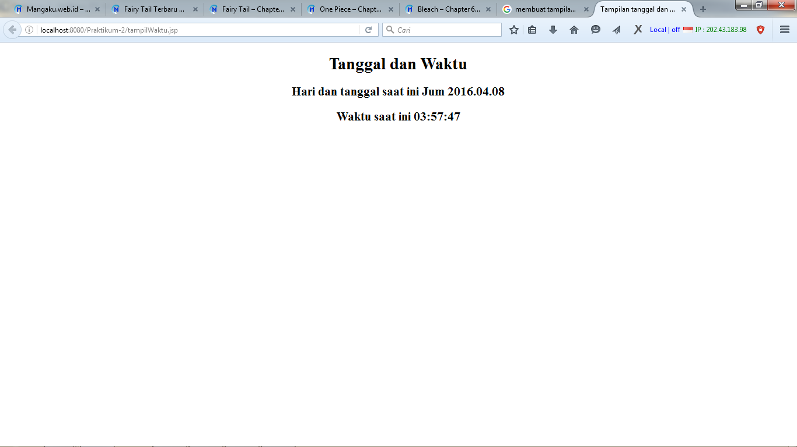

1. **Form input data dan tampilan simpanan data sementara nya**

**formInput.html**

|  |
| --- |
| <!DOCTYPE html>  <!--  To change this license header, choose License Headers in Project Properties.  To change this template file, choose Tools | Templates  and open the template in the editor.  -->  <!DOCTYPE html>  <html>  <head>  <title>Form Buku</title>  <meta charset="windows-1252">  <meta name="viewport" content="width=device-width, initial-scale=1.0">  <meta http-equiv="Content-Type" content="text/html; charset=UTF-8">  </head>  <body>  <center>  <h1>Input Data</h1>  <form action="formInput" method="POST">  <table border='0'>  <tr>  <td>Nama</td>  <td>: <input name="nama" type="text" /></td>  </tr>  <td>Email</td>  <td>: <input name="email" type="text" /></td>  </tr>  <td>Tanggal Lahir</td>  <td>: <input name="tanggal_lahir" type="text" /></td>  </tr>  <td>Alamat</td>  <td>: <input name="alamat" type="text" /></td>  </tr>  <tr>  <td><input type="submit" name="send" value="Kirim" /></td>  <td><input type="reset" name="reset" value="Reset" /></td>  </tr>  </table>  </center>  </form>  </body>  </html> |

**formInput.jsp**

|  |
| --- |
| /*  * To change this license header, choose License Headers in Project Properties.  * To change this template file, choose Tools | Templates  * and open the template in the editor.  */  import java.io.IOException;  import java.io.PrintWriter;  import javax.servlet.ServletException;  import javax.servlet.annotation.WebServlet;  import javax.servlet.http.HttpServlet;  import javax.servlet.http.HttpServletRequest;  import javax.servlet.http.HttpServletResponse;  /**  *  * @author ADAM01  */  @WebServlet(urlPatterns = {"/formInput"})  public class formInput extends HttpServlet {  /**  * Processes requests for both HTTP <code>GET</code> and <code>POST</code>  * methods.  *  * @param request servlet request  * @param response servlet response  * @throws ServletException if a servlet-specific error occurs  * @throws IOException if an I/O error occurs  */  protected void processRequest(HttpServletRequest request, HttpServletResponse response)  throws ServletException, IOException {  response.setContentType("text/html;charset=UTF-8");  String Nama = request.getParameter("nama");  String Email = request.getParameter("email");  String Tanggal_lahir = request.getParameter("tanggal_lahir");  String Alamat = request.getParameter("alamat");  PrintWriter out = response.getWriter();  try {  /* TODO output your page here. You may use following sample code. */  out.println("<!DOCTYPE html>");  out.println("<html>");  out.println("<head>");  out.println("<title>Tampil data Input</title>");  out.println("</head>");  out.println("<body>");  out.println("<center");  out.println("<h1>");  out.println("Verifikasi Data");  out.println("</h1>");  out.println("<table border='0'>");  out.println("<tr><td>Nama</td><td>: " + Nama + "</td></tr>");  out.println("<tr><td>Email</td><td>: " + Email + "</td></tr>");  out.println("<tr><td>Tanggal Lahir</td><td>: " + Tanggal_lahir + "</td></tr>");  out.println("<tr><td>Alamat</td><td>: " + Alamat + "</td></tr>");  out.println("</tr></table>");  out.println("</center");  out.println("</body>");  out.println("</html>");  } finally {  out.close();  }  }  // <editor-fold defaultstate="collapsed" desc="HttpServlet methods. Click on the + sign on the left to edit the code.">  /**  * Handles the HTTP <code>GET</code> method.  *  * @param request servlet request  * @param response servlet response  * @throws ServletException if a servlet-specific error occurs  * @throws IOException if an I/O error occurs  */  @Override  protected void doGet(HttpServletRequest request, HttpServletResponse response)  throws ServletException, IOException {  processRequest(request, response);  }  /**  * Handles the HTTP <code>POST</code> method.  *  * @param request servlet request  * @param response servlet response  * @throws ServletException if a servlet-specific error occurs  * @throws IOException if an I/O error occurs  */  @Override  protected void doPost(HttpServletRequest request, HttpServletResponse response)  throws ServletException, IOException {  processRequest(request, response);  }  /**  * Returns a short description of the servlet.  *  * @return a String containing servlet description  */  @Override  public String getServletInfo() {  return "Short description";  }// </editor-fold>  } |

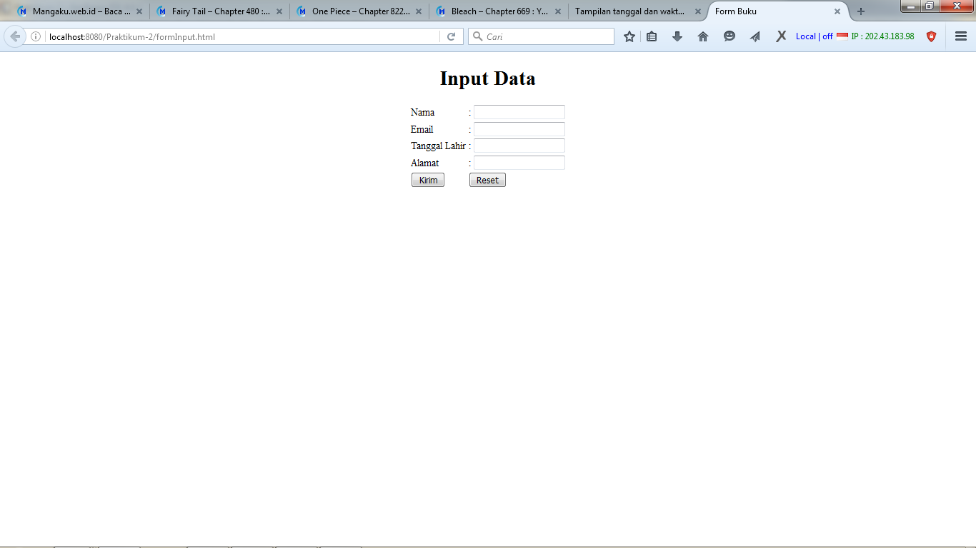

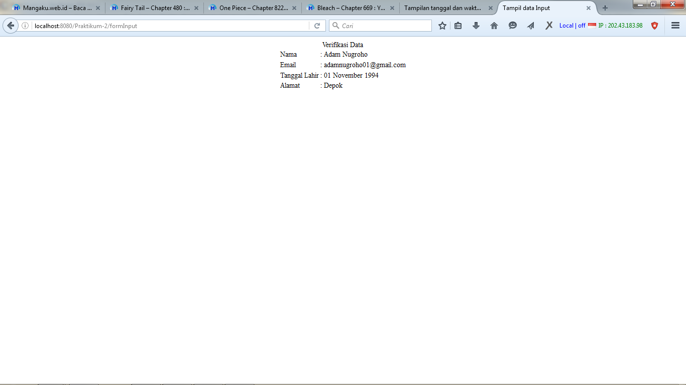

**Tampil data dari database JSTL + tampilan akhir**

tampilWaktu.jsp

|  |
| --- |
| <%--  Document : tampilWaktu  Created on : Apr 8, 2016, 3:29:36 PM  Author : ADAM01  --%>  <%@page import="java.sql.Time"%>  <%@page import="java.util.*"%>  <%@page contentType="text/html" pageEncoding="UTF-8"%>  <%@ page import="javax.servlet.*,java.text.*" %>  <%@ taglib prefix="x" uri="http://java.sun.com/jsp/jstl/xml" %>  <%@ taglib prefix="fn" uri="http://java.sun.com/jsp/jstl/functions" %>  <%@ taglib prefix="sql" uri="http://java.sun.com/jstl/sql_rt" %>  <%@ taglib prefix="c" uri="http://java.sun.com/jstl/core_rt" %>  <!DOCTYPE html>  <html>  <head>  <meta http-equiv="Content-Type" content="text/html; charset=UTF-8">  <title>Tampilan tanggal dan waktu sekarang</title>      <center>  <h1>Tanggal dan Waktu</h1>  </center>  <%  Date dNow = new Date( );  SimpleDateFormat dt = new SimpleDateFormat ("E yyyy.MM.dd ");  SimpleDateFormat ft = new SimpleDateFormat ("hh:mm:ss");  out.print( "<h2 align=\"center\">Hari dan tanggal saat ini " + dt.format(dNow) + "</h2>");  out.print( "<h2 align=\"center\">Waktu saat ini " + ft.format(dNow) + "</h2>");  %>    <h1>  Input Data Pada Form  </h1>  <p><a href="./formInput.html">Klik Disini</a></p>  <h2>DAFTAR PRODUK</h2>  <sql:setDataSource var="snapshot"  driver="com.mysql.jdbc.Driver"  url="jdbc:mysql://localhost/latihan_Prak2P4"  user="root" password=""/>    <sql:query dataSource="${snapshot}" var="result">  SELECT * FROM produk  </sql:query>    <table border="1" width="100%">  <tr>  <th>ID</th>  <th>Kode</th>  <th>Nama</th>  <th>Harga</th>  <th>Teakhir Update</th>  </tr>  <c:forEach var="row" items="${result.rows}">  <tr>  <td><c:out value="${row.id}"/></td>  <td><c:out value="${row.kode}"/></td>  <td><c:out value="${row.nama}"/></td>  <td>Rp. <c:out value="${row.harga}"/></td>  <td><c:out value="${row.terakhir_update}"/></td>  </tr>  </c:forEach>  </table>    </head>    </html> |

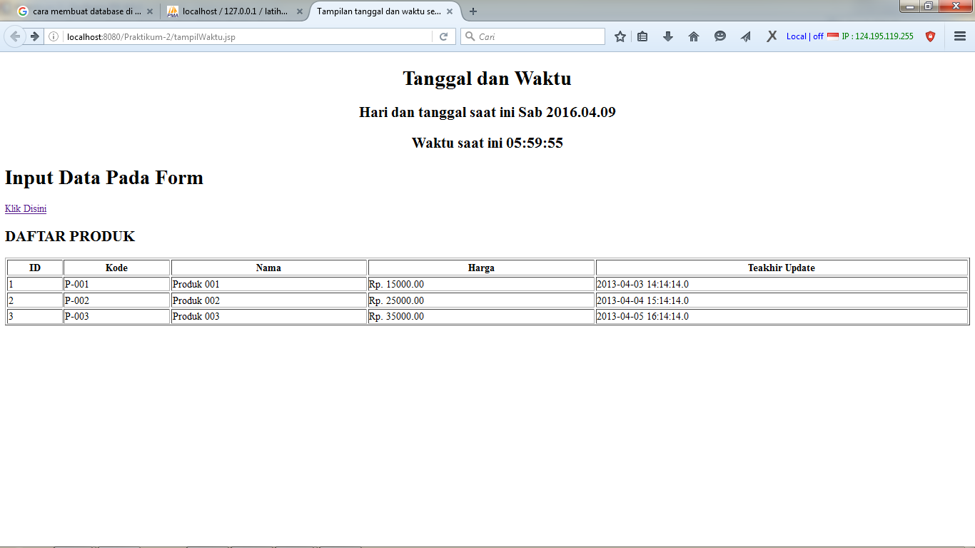

**Deployment**

|  |
| --- |
| cd D:\ADAM NUGROHO\KULIAH\KULIAH SEMESTER 6\Pemrograman 4\Tugas\Tugas 2\Praktikum-2; "JAVA_HOME=C:\\Program Files (x86)\\Java\\jdk1.8.0_20" cmd /c "\"\"C:\\Program Files (x86)\\NetBeans 8.0.2\\java\\maven\\bin\\mvn.bat\" -Dnetbeans.deploy=true -Dnetbeans.deploy.clientUrlPart=/tampilWaktu.jsp -Dmaven.ext.class.path=\"C:\\Program Files (x86)\\NetBeans 8.0.2\\java\\maven-nblib\\netbeans-eventspy.jar\" -Dfile.encoding=UTF-8 package\""  Scanning for projects...    ------------------------------------------------------------------------  Building Praktikum-2 1.0-SNAPSHOT  ------------------------------------------------------------------------  --- maven-dependency-plugin:2.6:copy (default) @ Praktikum-2 ---  --- maven-resources-plugin:2.5:resources (default-resources) @ Praktikum-2 ---  [debug] execute contextualize  Using 'UTF-8' encoding to copy filtered resources.  Copying 0 resource  --- maven-compiler-plugin:3.1:compile (default-compile) @ Praktikum-2 ---  Nothing to compile - all classes are up to date  --- maven-resources-plugin:2.5:testResources (default-testResources) @ Praktikum-2 ---  [debug] execute contextualize  Using 'UTF-8' encoding to copy filtered resources.  skip non existing resourceDirectory D:\ADAM NUGROHO\KULIAH\KULIAH SEMESTER 6\Pemrograman 4\Tugas\Tugas 2\Praktikum-2\src\test\resources  --- maven-compiler-plugin:3.1:testCompile (default-testCompile) @ Praktikum-2 ---  No sources to compile  --- maven-surefire-plugin:2.10:test (default-test) @ Praktikum-2 ---  Surefire report directory: D:\ADAM NUGROHO\KULIAH\KULIAH SEMESTER 6\Pemrograman 4\Tugas\Tugas 2\Praktikum-2\target\surefire-reports  -------------------------------------------------------  T E S T S  -------------------------------------------------------  Results :  Tests run: 0, Failures: 0, Errors: 0, Skipped: 0  --- maven-war-plugin:2.3:war (default-war) @ Praktikum-2 ---  Packaging webapp  Assembling webapp [Praktikum-2] in [D:\ADAM NUGROHO\KULIAH\KULIAH SEMESTER 6\Pemrograman 4\Tugas\Tugas 2\Praktikum-2\target\Praktikum-2-1.0-SNAPSHOT]  Processing war project  Copying webapp resources [D:\ADAM NUGROHO\KULIAH\KULIAH SEMESTER 6\Pemrograman 4\Tugas\Tugas 2\Praktikum-2\src\main\webapp]  Webapp assembled in [39 msecs]  Building war: D:\ADAM NUGROHO\KULIAH\KULIAH SEMESTER 6\Pemrograman 4\Tugas\Tugas 2\Praktikum-2\target\Praktikum-2-1.0-SNAPSHOT.war  ------------------------------------------------------------------------  BUILD SUCCESS  ------------------------------------------------------------------------  Total time: 2.179s  Finished at: Sat Apr 09 17:59:53 ICT 2016  Final Memory: 9M/21M  ------------------------------------------------------------------------  NetBeans: Deploying on GlassFish Server 4.1  profile mode: false  debug mode: false  force redeploy: true  Undeploying ...  In-place deployment at D:\ADAM NUGROHO\KULIAH\KULIAH SEMESTER 6\Pemrograman 4\Tugas\Tugas 2\Praktikum-2\target\Praktikum-2-1.0-SNAPSHOT |